Usability Study of Frostburg State University’s Directories & Maps Page

Fizza Zaman
Frostburg State University – COSC 631
Professor Flinn
August 9, 2019

Abstract – A university’s website is an entryway for information and services. Any page that is a part of a university website, should reflect the needs of the users. The aim of this paper is to study the usability of Frostburg State University’s Directories and Maps page by focusing on learnability by measuring effectiveness, efficiency, and satisfaction. The methodology consists of a remote usability survey that collects data from participants utilizing questions, tasks completed, and statement agreements. The prediction was that the Directories & Maps page would score low in efficiency, effectiveness, and satisfaction. The results revealed the page scored high in effectiveness, but average in both effectiveness and satisfaction.

Keywords – usability; university; website; learnability; survey; effectiveness; efficiency; satisfaction

1. Introduction
Since the invention of the Web, it has become a pervasive communication medium for organizations. The Web is different from software, and the nature of the Web poses new challenges to designers and developers who are trying to incorporate usability into their sites [3]. Usability can be defined in many ways as every designer wants to develop high-quality user experiences. The designers begin by determining user needs, generating multiple design alternatives and conducting usability testing, going beyond the vague notions of user friendliness, intuitive, and natural. Instead, they have a thorough understanding of the diverse community of users and the tasks they are trying to accomplish. Hence, great designers are committed to enhancing the user experience [1, pg. 13].
Interaction with the users leads to a well-chosen set of benchmark tasks that become the basis for usability goals and measures. The ISO 9241 standard Ergonomics of Human-System Interaction focuses on effectiveness, efficiency, and satisfaction, which is the learnability of a website. The following measures focus on the latter two goals for a more practical evaluation: time to learn, speed of performance, rate of errors by users, retention over time, and subjective satisfaction. Every designer would like to succeed in every measure, but there are often tradeoffs [1, pg. 14]. Universities incorporate usability in their websites, which serves as a source of academic, scientific, educational, and contact information for various audiences. These audiences contain both prospective and current students, parents, prospective faculty and staff, donors and alumni, with current students being the most frequent audience [2].
For this reason, designers’ approach to website design framework follows the concept of user-centered design (UCD) which considers the needs, wants, and limitations of the actual end users into account. Directly involving the intended users in this process gives a much-needed understanding of what users need. In addition to this, these designs are easier to learn, result in faster performance, reduce user errors, and encourage users to explore features that go beyond the minimum. While the main premise of UCD is straightforward, it is a significant challenge, demanding usability testing for ongoing development [1, pg. 112]. Since websites are used across the world, remote usability tests can be conducted online to avoid unnecessary complexity and cost of bringing participants to a lab. This makes it possible to have participants with more diverse backgrounds and adds to the realism as participants do their test in their own environment with their own equipment [1, pg. 157].

3. Methodology
In this usability study, the step-by-step usability guide was used, as seen in Figure 1, to form a plan, evaluate the website, learn about the users, conduct task analysis and analyze the data [1, pg. 149].

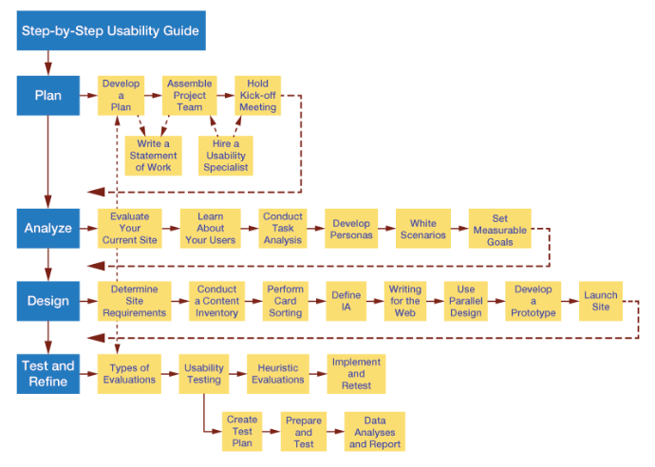
Figure 1 - Step-by-Step Usability Guide

The remote usability testing method was used to evaluate Frostburg State University’s Directories and Maps page found at the URL https://www.frostburg.edu/university-directories.php. In this method, a qualitative approach was used to collect data. This data was analyzed to produce both qualitative and quantitative results. A total of 20 participants voluntarily took the usability survey to accomplish this usability study.

3.1 Instruments Used
This usability test was conducted remotely by having participants volunteer to take a usability survey. Surveys are familiar, inexpensive and acceptable form of conducting usability tests as users can easily grasp the notion of surveys. The key to the success of a survey design are validity and reliability in conjunction with administration and data analysis [1, pg. 160]. The survey was created using Google Forms, which allows for both the creation and analysis of surveys without needing special software. Instant results are provided as the responses come in. These results can be summarized by charts and graphs. Once the allotted time frame of two-weeks to participate in this usability study concluded, responses were no longer collected. The survey was shared by emailing the Google Form link to the participants.

3.2 Preparing and Designing the Survey Questions
For a survey design to be successful, methods of statistical analysis and presentation must be developed before the distribution of the survey. Google Form’s satisfies this requirement by providing a summary of all responses with visual data diagrams in the form of pie charts and bar graphs. These responses can be automatically recorded by exporting them to a spreadsheet. Biased samples of respondents can produce errors in the results; hence it is necessary to collect information regarding participants’ characteristics such as background demographics, experience with computers, familiarity with features, and feelings after using an interface [1, pg. 160]. Survey items can use various approaches. One of these approaches is asking participants a series of statements according to the Likert scale:

Strongly disagree Disagree Neutral Agree Strongly agree

A list of statements helps identify problems users are having, giving an indication of what needs to be redone [1, pg. 161]. These statements are provided by using the System Usability Scale (SUS) with which users rate their agreement on a 5-point scale. Half of the statements are positively worded, and the other half are negatively worked. The score computed is viewed as a percentage [1, pg. 162]. Explicit acceptance criteria must be established to measure usability. This can be done by measuring the speed of task performance and subjective user satisfaction [1, pg. 165].

3.3 Participants
Most frequent visitors of university websites are generally the students attending the university. For this reason, the survey was shared with students enrolled in the Summer 2019 class of COSC 631 – Web Development at Frostburg State University. All participants took the survey voluntarily and anonymously. Participants used their own equipment and completed the survey in their own environment.

3.4 Usability Survey
The survey starts with asking the age of the participant. Six choices were presented to choose from: Under 18; 18 – 24; 25 – 34; 35 – 44; 45 -54; 55+. Next, participants were asked to rate their computer skills ranging from Level 1 to Level 5. Level 1 consists of fundamental skills such as typing or using a mouse. Level 2 consists of basic computing and application skills. Level 3 consists of intermediate computing and application skills. Level 4 consists of advanced computing and application skills. Level 5 consists of proficient computing, application, and programming skills. The purpose of this part of the survey was to collect information regarding the participants’ characteristics and experience with computers. Once these questions are completed, participants are asked to navigate to the URL for Frostburg State University’s Directory & Maps page: https://www.frostburg.edu/university-directories.php. The next question asks participants if they have used this page before. Three options are presented to choose from: yes, no, maybe. This collects additional participants’ characteristics of familiarity with features and the website.
To measure usability, participants are asked to complete two tasks on the Directory & Maps page. All participants self-report the amount of time it took for the task’s completion and rated the difficulty of this task. The first task asked to find the Registrar’s office’s contact number. The second task was to find the contact number for the Computer Science and Information Technologies department. Four options of time spent were provided to choose from for both tasks: Less than 2 minutes; 2 – 5 minutes; more than 5 minutes; I could not complete this task. Then, the difficulty of both tasks was rated by providing a 4-point scale: 0 – Very Easy, 1 – Easy, 2 – Medium, 3 – Difficult, 4 – Very Difficult.
To collect feelings after using the interface and help identify problems users were having, five of the ten System Usability Scale (SUS) statements were used. Each participant was asked to rate their agreement, using a Likert scale with an assigned point value to measure results quantitively, as seen in Figure 2. Strongly disagree was assigned a point value of 1. Disagree was assigned a point value of 2. Neutral was assigned a point value of 3. Agree was assigned a point value of 4. Strongly Agree was assigned a point value of 5.

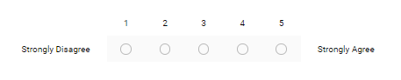
Figure 2 - Likert Scale with Assigned Point Value

5. Usability Survey Responses
The first demographic questions revealed an equal number of participants in the ages 18 – 24 and 25 – 34, making up 70% of participants. Ages between 35 – 44 consisted of 15% of participants. Ages between 45 – 54 consisted of 10% of participants, leaving 5% in the 55+ age group. This means only 5% of the participants would be classified as elderly. These results are demonstrated in Figure 3.

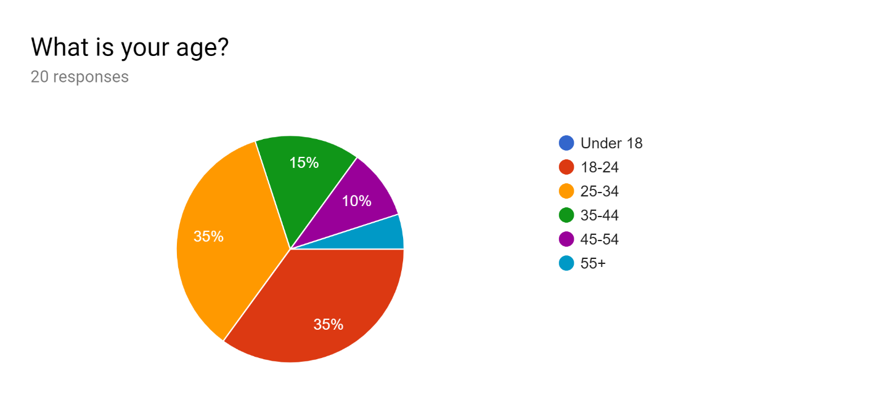
Figure 3 - Age of Participants

The second question rated the computer skills of the participants as seen in Figure 4. The participants rated their computer skills as either Level 1, 2, 3, 4, or 5: 15% rated as Level 2; 35% rated as Level 3; 20% rated as Level 4; 30% rated as Level 5. The results show that all participants possess basic computing and applications skills, which is all a user need to be able to use a website.
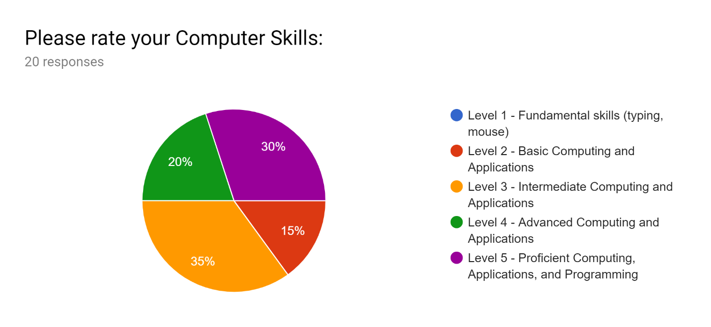
Figure 4 Participant’s Computer Skills

After navigating to https://www.frostburg.edu/university-directories.php, participants were asked if they have used this page before, as seen in Figure 5. The response “No” contains the most participants at 60%, “Yes” is 30% and “Maybe” is 10%. This shows that most participants were not familiar with this website interface before this usability study was conducted.
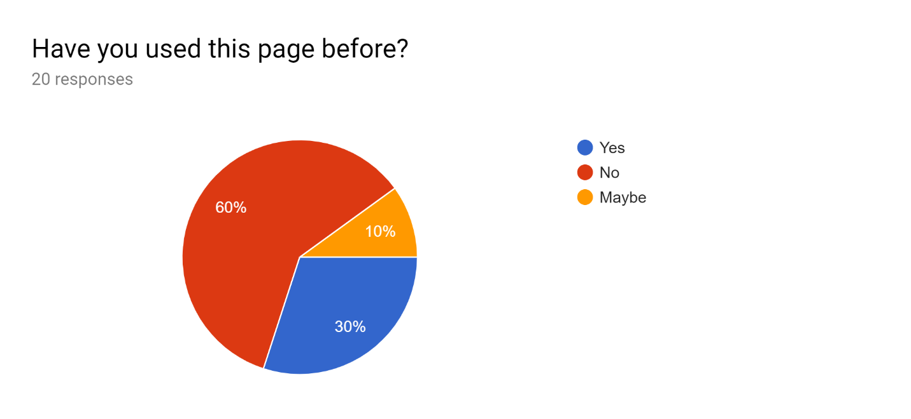
Figure 5 – Participant’s Website Familiarity

Two tasks were designed for completion. Both tasks measured the time spent for participants to complete the task and had participants rate the difficulty of the task. Task one was to find the Registrar’s office’s contact number. Task two was to find the contact number for the Computer Science and Information Technologies department. Task one was completed in less than 2 minutes by 70% of participants; 25% of participants spent 2 – 5 minutes; 5% could not complete this task, as seen in Figure 6.
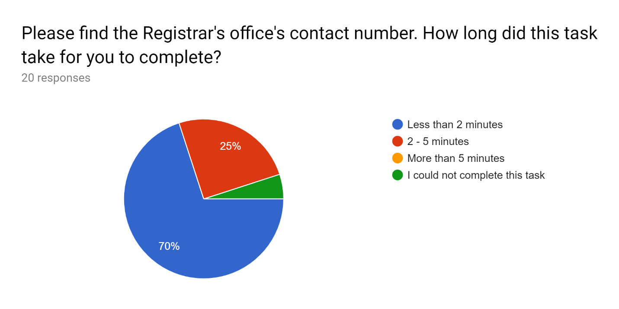Figure 6 – Time Spent Completing Task One

The rated difficulty of task one shows that 30% of participants found the task very easy; 15% found the task easy; 45% rated the difficulty of this task as medium; 10% found this task difficult; 0% found this task very difficult, as seen in Figure 7. This means that 55% of participants found this task to be of medium or higher difficulty.

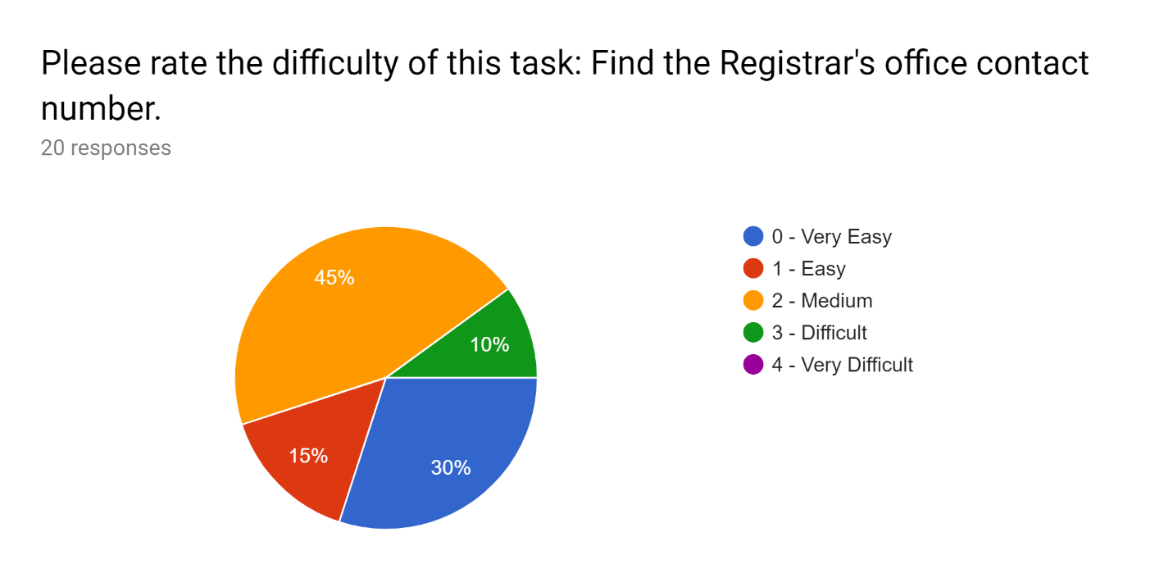
Figure 7 – Rated Difficulty of Task One

Task two’s completion results showed that 85% of participants completed this task in less than 2 minutes and the remaining 15% of participants needed 2 – 5 minutes to complete this task, as seen in Figure 8. No participants spent more than 5 minutes completing the task or were unable to complete this task.
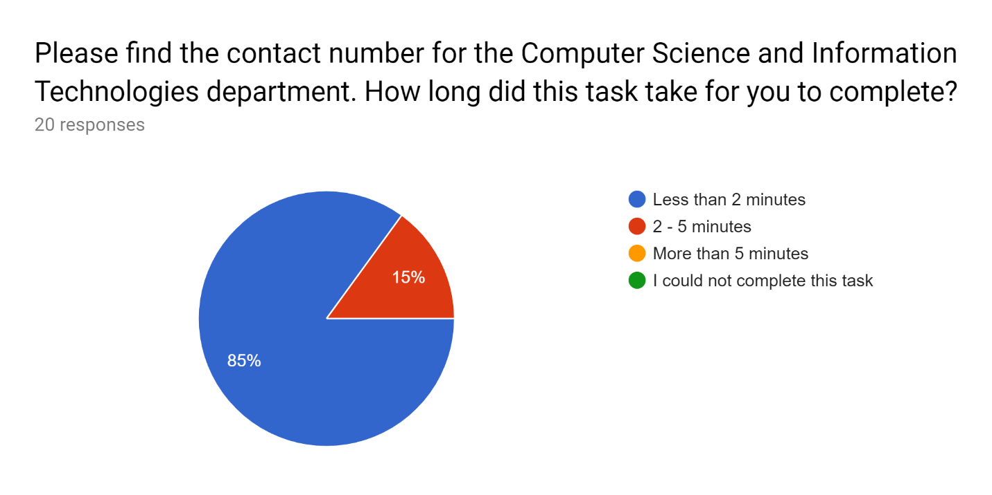Figure 8 – Time Spent Completing Task Two

Figure 9 shows the rated difficulty of task two. Most participants found this task to be easy, making up 45% of the respondents; 35% found this task to be of medium difficulty; 15% found this task to be very easy; 5% found this task to be difficult. This means that 60% of participants found this task to be easy or very easy.
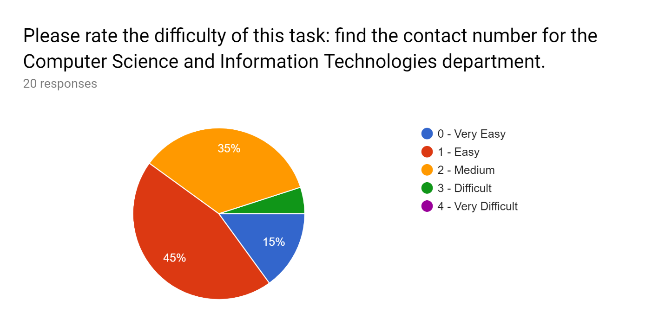
Figure 9 – Rated Difficulty of Task Two

The last part of the usability survey consisted of SUS statements measured using a Likert scale with an assigned point value system. The responses to these statements are shown in Figures 10 – 14. Section 6 will discuss the SUS Statement results in more detail.
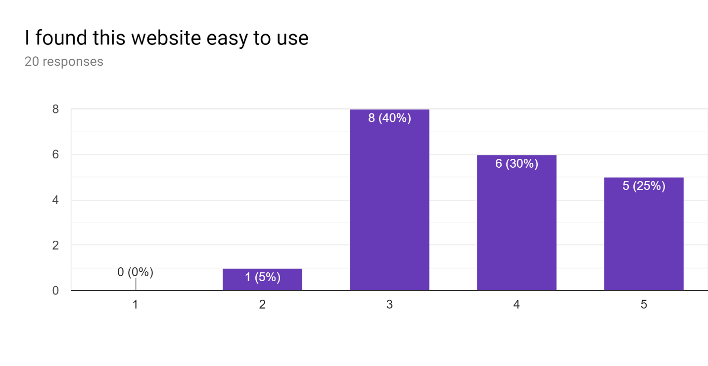
Figure 10 – First SUS Statement’s Response

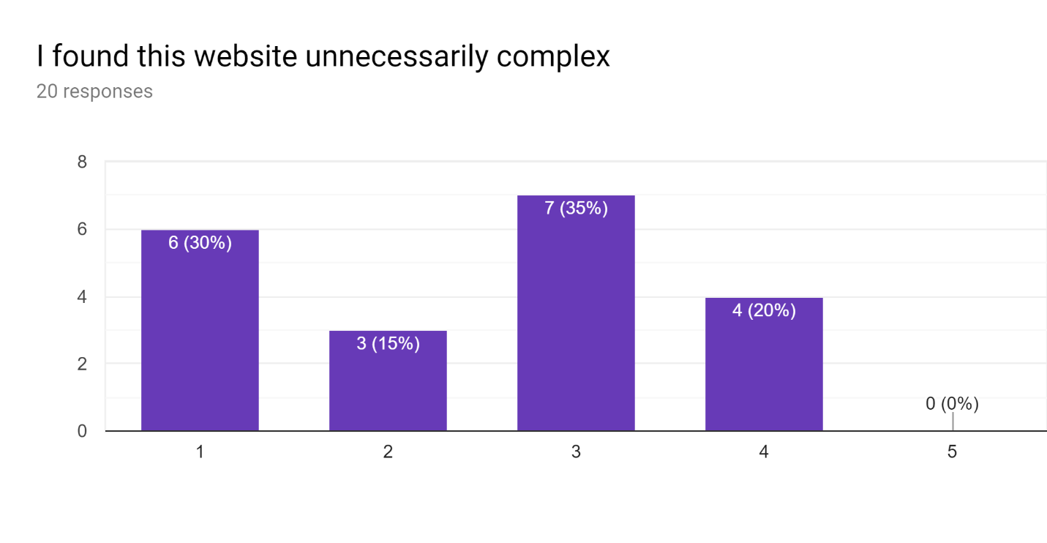
Figure 11 – Second SUS Statement’s Response
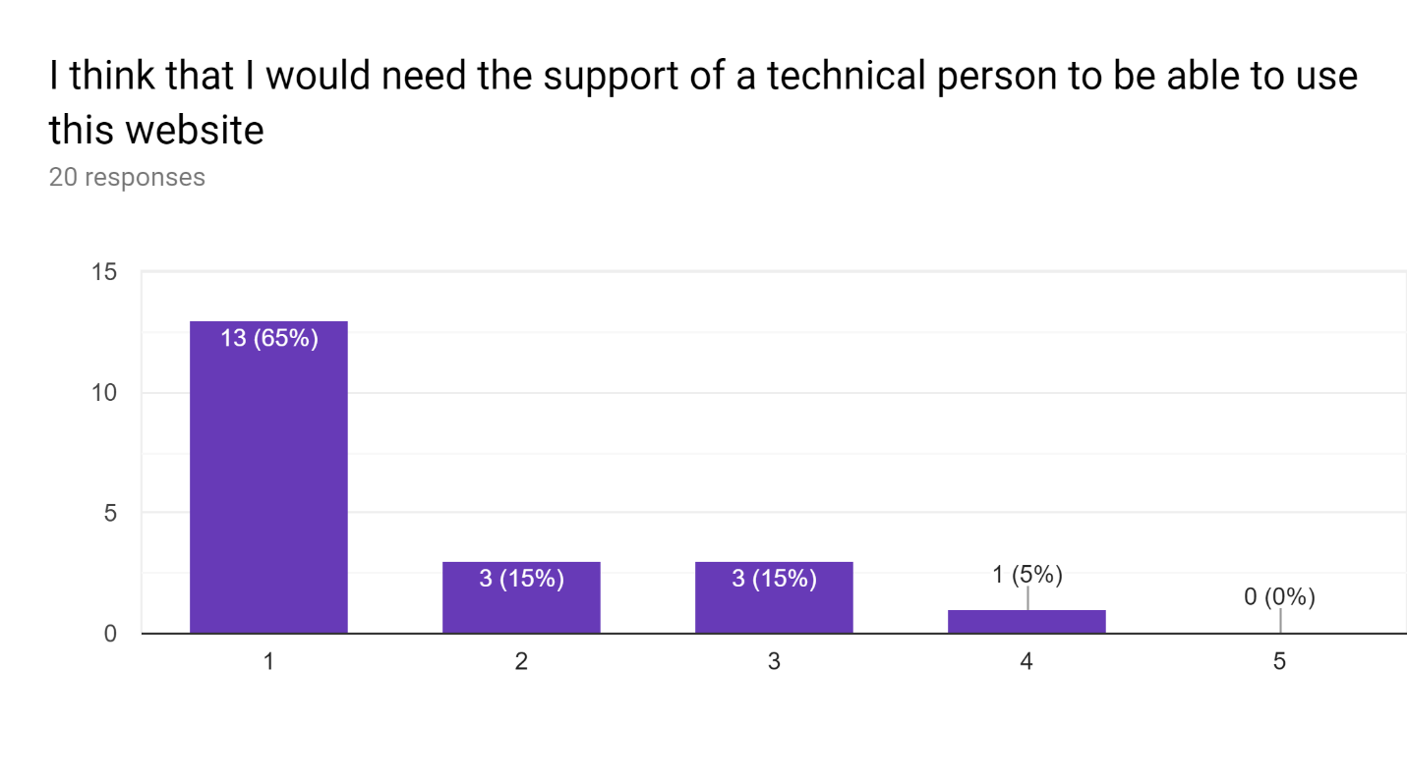
Figure 12 – Third SUS Statement’s Response
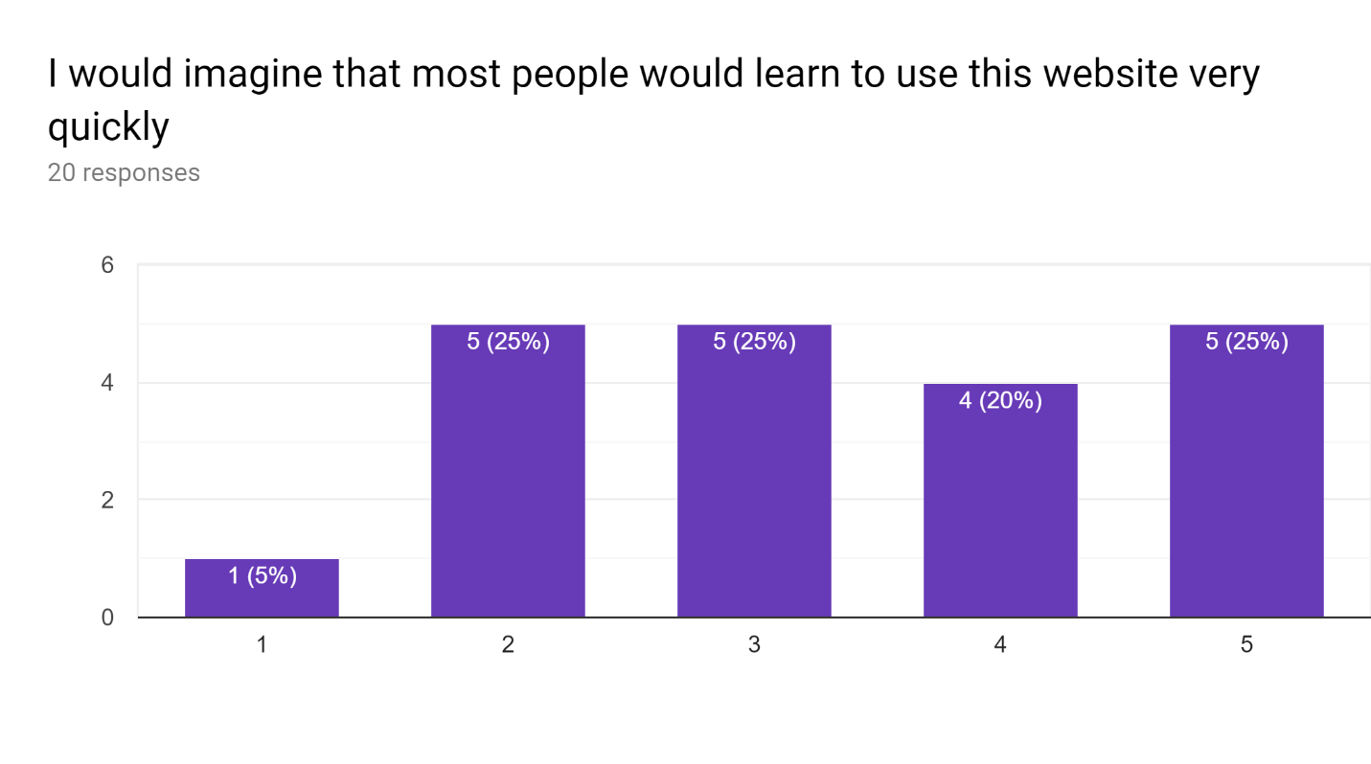
Figure 13 – Fourth SUS Statement’s Response
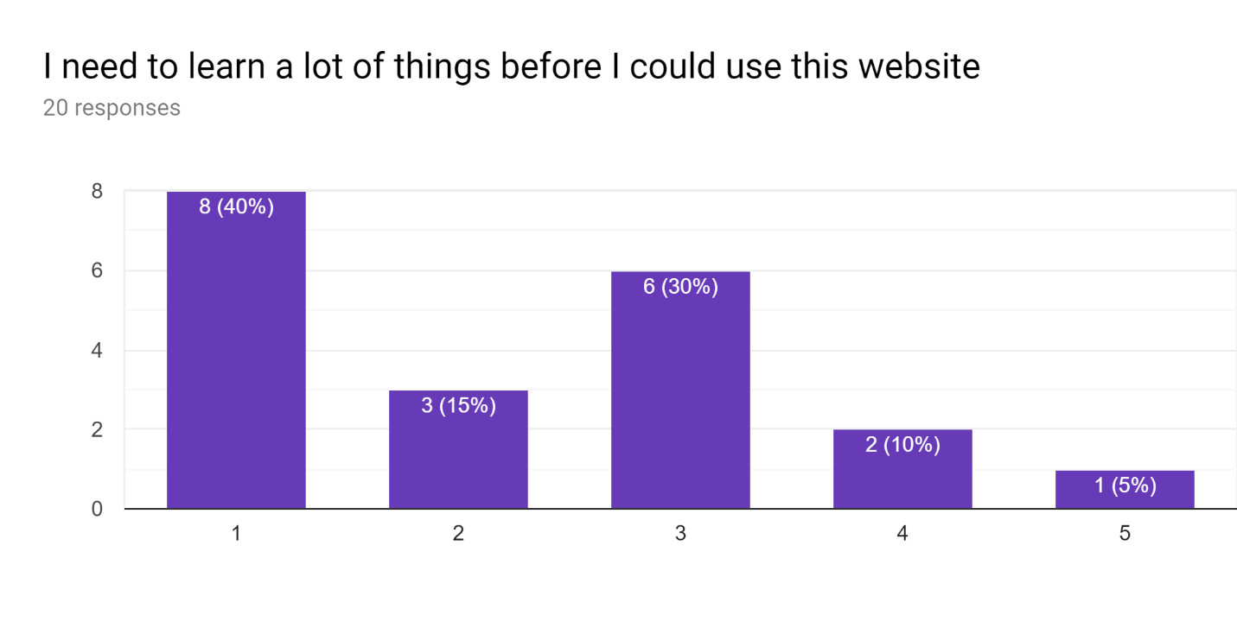
Figure 14 – Fifth SUS Statement’s Response

6. Results Discussion
This usability study focuses on effectiveness, efficiency, and satisfaction, which is the learnability of a website. Effectiveness and efficiency was measured by the task completion and time spent completing the task. The SUS Statement results were used to test satisfaction [4]. Figure 15 summarizes the SUS Statement results.

Participant Number | I found this website easy to use | I found this website unnecessarily complex | I think that I would need the support of a technical person to be able to use this website | I would imagine that most people would learn to use this website very quickly | I need to learn a lot of things before I could use this website
1 | 2 | 4 | 3 | 2 | 4
2 | 4 | 2 | 1 | 4 | 1
3 | 3 | 4 | 4 | 3 | 3
4 | 3 | 3 | 1 | 3 | 1
5 | 3 | 3 | 1 | 3 | 3
6 | 4 | 2 | 1 | 4 | 2
7 | 4 | 3 | 2 | 4 | 3
8 | 3 | 3 | 2 | 2 | 4
S9 | 4 | 1 | 1 | 5 | 1
10 | 3 | 3 | 2 | 2 | 3
11 | 5 | 1 | 1 | 5 | 1
12 | 5 | 1 | 1 | 5 | 5
13 | 3 | 3 | 1 | 3 | 1
14 | 4 | 2 | 1 | 4 | 2
15 | 3 | 4 | 3 | 1 | 3
16 | 5 | 1 | 1 | 5 | 1
17 | 3 | 3 | 3 | 3 | 3
18 | 5 | 1 | 1 | 5 | 1
19 | 5 | 1 | 1 | 2 | 1
20 | 4 | 4 | 1 | 2 | 2

Figure 15 – SUS Statements’ Result Summary

6.1 Efficiency
Efficiency is the measure of resources spent in order to achieve a task within the interface. This study defines resource as the time spent. Results show that majority of participants spent less than two minutes completing both tasks, with 15 – 25% of participants taking 2 – 5 minutes. 5% of participants could not complete one of the two tasks. Finding the Registrar’s office’s contact number was rated to be of medium difficulty or higher by 55% of participants. 40% rated finding the contact number for the Computer Science and Information Technologies department as medium difficulty or higher. The efficiency results of the Directories and Maps page show an average score in efficiency, which means this page should be redesigned to improve efficiency.

6.2. Effectiveness
Effectiveness measures the level of completeness of the given task. Both tasks ask participants to find contact information using the Directories and Maps page. Effectiveness would be proven by finding true information or completing the task given. This can be measured by the percentage of succeeded participants in the usability testing. For task one, 95% of participants completed the task. For task two, 100% of participants completed the task. The effectiveness results of the Directories and Maps page show a high score in effectiveness.

6.3 Satisfaction
Satisfaction measures the user’s feelings after using the website. The results were derived by computing the average score for each of the five statements. A total score of under 3 means disagree. A total score of over 3 means agree. A total score of 3 means neutral. Figure 16 shows the average scores for each statement, followed by the final verdict: Agree, Disagree, or Neutral.

I found this website easy to use | I found this website unnecessarily complex | I think that I would need the support of a technical person to be able to use this website | I would imagine that most people would learn to use this website very quickly | I need to learn a lot of things before I could use this website
3.75 | 2.45 | 1.6 | 3.35 | 2.25 | Average Score
Agree | Disagree | Disagree | Agree | Disagree | Verdict
0.9 | 1.1 | 0.9 | 1.3 | 1.3 | Standard Deviation
2.8 | 1.3 | 0.7 | 2.1 | 1.0 | Low Range
4.7 | 3.6 | 2.5 | 4.6 | 3.5 | High Range

Figure 16 – SUS Statement Average Scores

Results show that most participants agree that the website was easy to use; most participants disagree that the website was unnecessarily complex; most participants disagree with the statement that they would need the support of a technical person to use the website. Most participants agree that this website is quick to learn. Most participants disagree that they needed to learn a lot of things before using the website. The standard deviation applied to the average creates a range. Figure 16 shows the low and high number in this range. Three out of five SUS statements’ range shows the agreement results could turn into either agree or disagree, as the range goes significantly above and below 3, which is neutral. For this reason, the satisfaction rating of the Directories and Maps page was found to be average, which means this page should be redesigned to improve satisfaction.

7. Proposed Prototype
The main menu on the Directories and Maps page shows three distinctive categories in capitalized, black font: Find people & places, more directories & resources, and additional resources. Each category contains a list of options formatted in a bullet list, with red, clickable fonts, which redirect the user to the page that contains the information. This menu is shown in Figure 17.
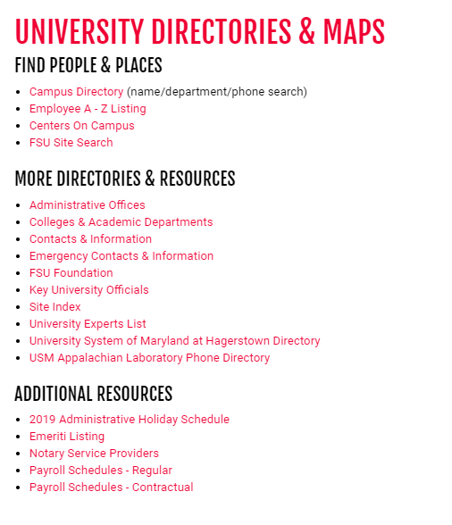
Figure 17 – Directories & Maps Page Main Menu

To complete task one, find the registrar’s office’s contact number the user clicks administrative offices under more directories & resources. This redirects the user to a different page that lists all administrative offices at Frostburg State University, as seen in Figure 18.

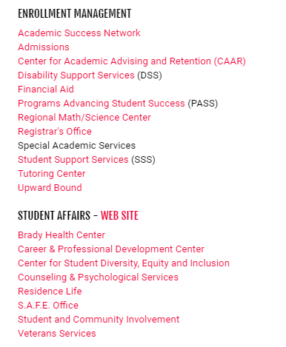
Figure 18 – Partial View of Administrative Offices Page
At this point, the user is once again redirected to the Registrar’s Office page, as seen in Figure 19. The important thing to note here is the three different levels a user must go through to find this information.
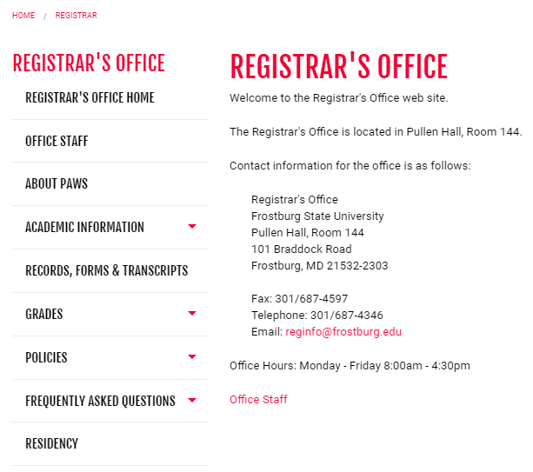
Figure 19 – Partial View of Registrar’s Office Page

This is chosen for the proposed redesign prototype due to its usability rating being low in efficiency, with 25% of participants taking 2-5 minutes to complete the task and 5% unable to complete this task. The task was rated as medium or higher in difficulty by 55% of participants. To improve efficiency, an additional category is created on the Directories and Maps page “Quick Links for Current Students,” as current students frequent visit university website. Once efficiency increases, in conjunction with the high effectiveness rating, it should in turn improve satisfaction. Figure 20 shows the addition of this category with registrar’s office, financial aid, bookstore and university & student billing as clickable links which will redirect students to the contact information.
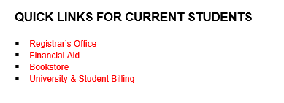
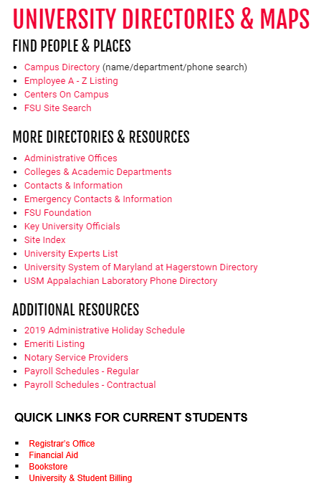
Figure 20 – Directories & Maps Page Redesign Prototype

8. Conclusion
The purpose of this study was to evaluate the Directories and Maps page of Frostburg State University’s website according to usability testing criterions. When the results were collected and analyzed, the usability level of the page was found to be high in effectiveness, but average in both efficiency and satisfaction. This shows that participants had usability issues with some parts of this page. By analyzing the results for the tasks completed, it was discovered that finding the Registrar’s office’s contact number was considered a difficult task by majority of the participants, leaving one unable to complete this task. The second task was considered easy by the majority and all participants completed the task, leading to the conclusion that if the Registrar’s Office’s contact number was more accessible and easier to find, this would improve efficiency and satisfaction of the website. Hence, a redesigned prototype is proposed for the Directories and Maps page, where a section is added providing quick links to current students at Frostburg State University. Further usability testing is needed so that it can be applied to the redesigned prototype for this page to ensure that both efficiency and satisfaction of this page have increased.

References

- B. Shneiderman, Designing the user interface: strategies for effective human-computer interaction. Boston: Pearson, 2018.
- E. Caglar and S. A. Mentes, “The usability of university websites,” International Journal of Business Information Systems, 2012.
- K. R. Pierce, “Web Site Usability Report for Harvard University ,” Mar. 2005.
- “Usability Level of a University Web Site,” Procedia - Social and Behavioral Sciences, 20-Jan-2014. [Online]. Available: https://www.sciencedirect.com/science/article/pii/S1877042813049963.

Appendix A

Usability Study Schedule

7/13/19 – 7/19/19:
Review Flinn study and Designing the User Interface book to obtain information on what type of questions/information should be collected.

7/20/19 – 7/23/19:
Create a survey using Google Forms

7/23/19:
Send the survey link via email to the students of COSC 631 Web Development class at Frostburg State University, with a two-week time frame to obtain the responses.

7/29/19:
- Send a reminder email to participate in Usability Study.
- Create an outline for the usability study paper based on sample research papers read.

8/2/19:
- Send another reminder email to participate in Usability Study.
- Write the Introduction, Keywords, & Methodology in the usability study paper.

8/6/19:
Stop accepting responses.

8/6/19:
- Export the data collected to a spreadsheet.

8/6/19 – 8/9/19:
- Finish writing the usability study paper, including a prototype design derived from the study.
- Review the paper, rubric, and requirements on canvas.
- Create a Google Drive folder and upload the usability study paper, results spreadsheet, and data visualizations. Also add this to a shared folder on my OneDrive.

8/9/19:
- Proofread the paper again.
- Submit the links for both folders before 11:59 pm on August 9, 2019.

